**ECEN5823 Final Project Team Proposal**

**Project Name:** Intelligent Agriculture Control System

**Members:** Victor Kronberg

1. **Project Status**
   1. Thus far, the sensor breakout boards have been acquired from SparkFun, header pins have been soldered on and they are connected to a breadboard for testing and firmware development. The initial skeleton codebase has been checked out (btmesh) and functionality such as timer, gpio, and display have been fully ported over from other projects. Initial ADC initialization code has been implemented, but not fully tested. Pins have been selected for ADC input.
   2. Challenges so far have been finding time. I have not hit the meat of the technical portion, so no challenges there so far.
2. Project Overview:

With a rapidly increasing population and limited fresh water resources for agriculture, utilizing our resources as efficiently as possible become ever more critical in the coming years. On top of that, high water prices and global agricultural competition mean that U.S. farmers need every advantage that they can get in order to stay financially competitive.

The idea behind this project is to provide a modular, scalable wireless solution for monitoring and controlling soil conditions in an agricultural setting in order to optimize watering and fertilization to give the farmer the greatest yield per dollar spent on resources. This includes soil moisture level, soil temperature, sun exposure, and mineral content. There would also be sensors for monitoring water flow for irrigation and mineral content in fertilizer applications. This information would be fed into an intelligent platform that utilizes AI to help a farmer to optimize their water usage and soil treatments based on the soils’ response to watering and fertilizer applications. The platform would also be able to

By making this solution scalable and modular, it could be deployed on farms of any size – from backyard vegetable boxes to farms that encompass thousands of acres. The production version of this product would utilize Bluetooth Mesh, but as a proof-of-concept since I am a team of only 1 student, a single low-power node and associated friend node will be used.

1. Major Requirements:
   1. Low-power and low-cost soil sensor module
      1. Battery powered and can be self-powered for multiple years without maintenance
      2. Sense soil temperature, moisture content, mineral content, soil air permeability, and light exposure
   2. Data collection module with location-detection capabilities
      1. Requires higher power consumption than sensor module so persistent power source is needed (solar or wired)
      2. Receives data from sensors within its range, stores that data and relays the data
      3. Can sense location via GPS module
   3. Water flow sensor module
      1. Needs to be able to monitor volume of water applied to field and location of where that water was applied
      2. Also needs to be able to control flow of water
   4. Fertilizer sensor module
      1. Needs to be able to monitor mineral content and volume of fertilizer applied and where it was applied to
      2. Also needs to be able to control the amount of fertilizer applied
   5. Weather sensor module
      1. Needs to be able to monitor temperature, wind speed & direction, humidity, barometric pressure, and rainfall
      2. Co-located with data collection module
   6. Crop status module
      1. Needs to be able to monitor status of crop in a measureable way (e.g. – crop height and color via cameras)
   7. Internet connected module
      1. Receives data from mesh sensor network and uploads data to IoT platform
   8. IoT platform
      1. Platform would receive data from all sensors and apply AI to help identify optimal conditions for watering/applying fertilizer, how often to water, and how much fertilizer to use
      2. Platform would also be connected to the Internet in order to utilize NOAA weather data to aid in prediction of optimal watering times
2. High Level Design
   1. The high-level solution would consist of a Bluetooth Mesh deployment with the following nodes:
      1. LPN: Soil Sensor Module (4X per friend node)
         1. Fixed location
         2. Small battery
      2. Friend/Relay Node: Data collection node with weather sensor module
         1. Fixed location
         2. GPS-enabled location information
         3. Persistent memory
         4. Large battery capacity or wired installation
         5. Solar power to supplement battery if not wired
      3. Node: Water flow sensor/control
         1. Mobile location
         2. Senses and sends water flow status information
         3. Receives control messages from relay nodes to control rate of flow
            1. Utilizes solenoid valve or similar
         4. Relay node receives data and tags its location to it – done by closest relay in range
      4. Node: Fertilizer sensor
         1. Mobile location
         2. Senses and sends fertilizer mineral content and volume information
         3. Receives control messages from relay nodes to control rate of dispersion
         4. Relay node receives data and tags its location to it – done by closest relay in range
      5. Relay Node: Internet Gateway
         1. Fixed location
         2. Receives sensor data and uploads it to IoT platform
         3. Receives control data from IoT platform and relays to Mesh network
         4. Could also be a data collection node (ii)
         5. Large battery capacity or wired installation
         6. Solar power to supplement battery if not wired
   2. **Block Diagram**

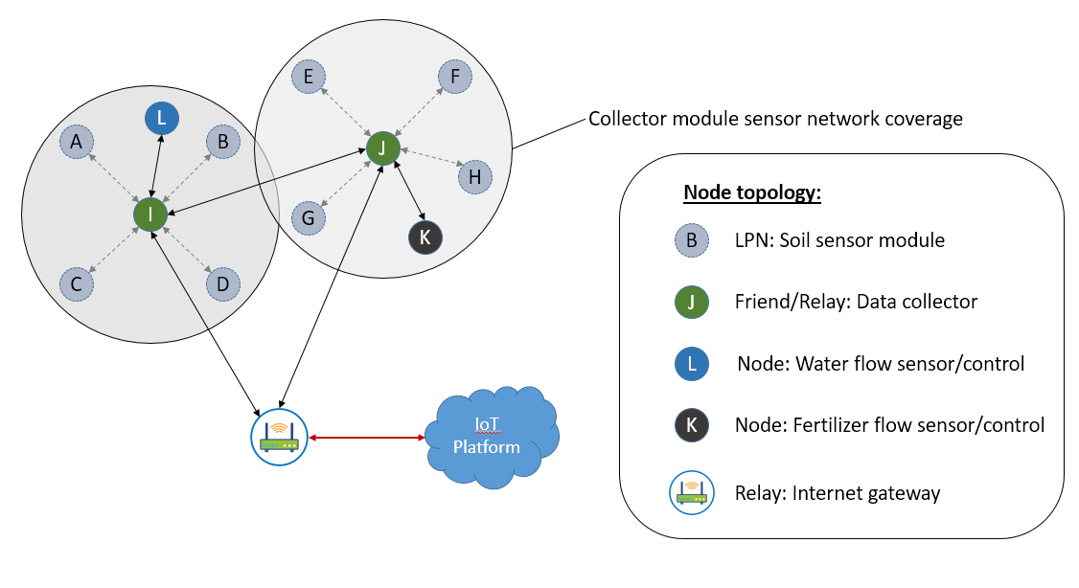

**Figure 1: Proposed network topology**

*NOTE: Nodes K and L are mobile and can travel between collector module zones*

*Coverage of Collector modules will extend over entire field*

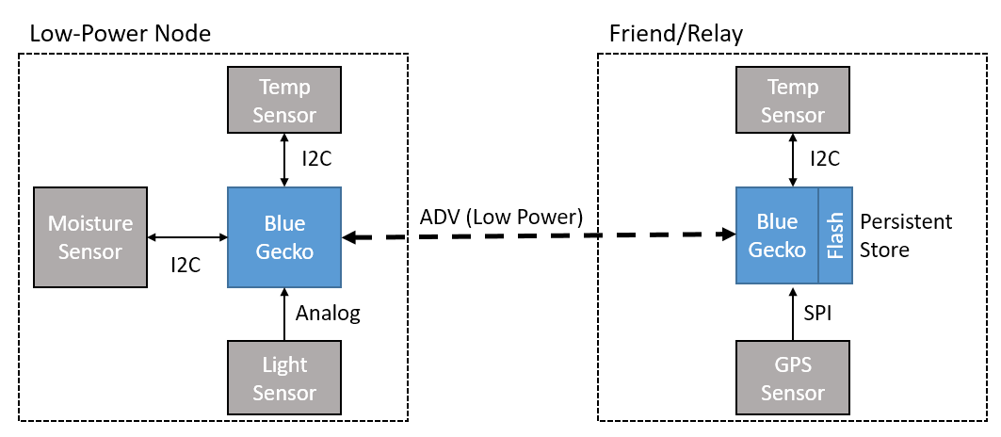

**Figure 2: Block diagram of nodes and sensors to be implemented**

* 1. **Sensors and data**
     1. **Soil Sensor Node – LPN: Publish data every 1-5 minutes**

|  |  |  |  |
| --- | --- | --- | --- |
| **Sensor** | **Data type** | **Data rate** | **Property Measured** |
| Capacitive moisture | I2C | 100kbps | Soil moisture content |
| Airflow sensor | Analog |  | Soil air permeability |
| Electrochemical sensors | Analog (ADC) |  | Soil chemical composition (pH, fertility, etc.) |
| Ambient light sensor | Analog (ADC) |  | Ambient light |
| Humidity & Temperature | I2C | 100kbps | Soil/surface temperature |

* + 1. **Data Collection/Weather Station – Relay/Friend: Transmit data every minute**

|  |  |  |  |
| --- | --- | --- | --- |
| **Sensor** | **Data type** | **Data rate** | **Property Measured** |
| GPS | I2C, SPI, UART or USB | 9600bps-12Mbps | GPS location |
| Anemometer | Analog (ADC) |  | Wind speed |
| Wind Vane | Analog (ADC) |  | Wind direction |
| Rain gauge | Analog (ADC) |  | Rainfall amount |
| Barometric pressure | SPI or I2C | 100kbps | Barometric (atmospheric) pressure |
| Ambient light sensor | Analog (ADC) |  | Ambient light |
| Humidity & Temperature | I2C | 100kbps | Air temperature and relative humidity |

* + 1. **Water flow meter – Node: Publish data every 1 minute**

|  |  |  |  |
| --- | --- | --- | --- |
| **Sensor** | **Data type** | **Data rate** | **Property Measured** |
| Flow sensor (Hall Effect) | GPIO (pulse) | N/A | Water flow rate |

* + 1. **Fertilizer flow meter – Node: Publish data every ½ minute**

|  |  |  |  |
| --- | --- | --- | --- |
| **Sensor** | **Data type** | **Data rate** | **Property Measured** |
| Load sensor (strain gauge) | Analog (ADC) |  | Weight of fertilizer remaining in hopper – use to calculate rate of dispersion |

1. **Sub-projects for ECEN5823 Final Project**:
   1. Soil sensor module and data collection module:
      1. Subsystem proof-of-concept will utilize Bluetooth LE as there is only 1 person in team. This subsystem is responsible for sensing the properties of the soil and transmitting that information back to a “collector”. The “collector” stores the sensor data in persistent memory in case of network outage or system/power failure. In a full deployment, the “collector” would also transmit and relay sensor data towards the Internet gateway.

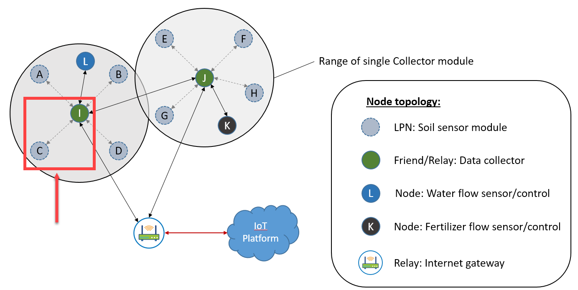

**Figure 3: Nodes to be implemented**



**Figure 4: Block diagram of nodes and sensors to be implemented**

* + 1. Sensors to be implemented:
       1. Soil moisture sensor (Server)
       2. Ambient light sensor (Server)
       3. Temperature & humidity sensor (Both)
       4. *Optional –* GPS (Client)

1. **Project Team Members:**
   1. Victor Kronberg
2. **Verification Plan**
   1. *Attached in “documents” folder*